Spore Genetics and Inheritance Activity
Background:
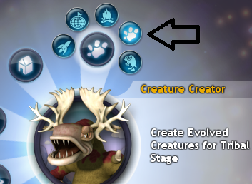
This activity is designed as a fun way to demonstrate genetics and inheritance, using the computer simulation game Spore, from Electronic Arts (available at store.origin.com and most retailers). Spore places the player as a species of creature on a foreign planet tasked with surviving and thriving from unicellular organism to advanced space civilization stages, and has value as a learning tool in several ways. This activity focuses on the creature creator tool. Several versions of the creature creator exist (2d online, free trial version, full game), so depending on your resources you may choose the best one for you, though the activity proceeds the same. Due to this flexibility and variation in available resources, the teacher may lead the students in the activity, or the students may work independently.
Instructions:
After starting the program, select Create, then Creature Creator, then Creature Creator again (at right).
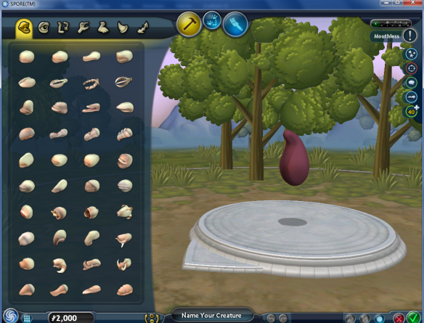
- Click to launch the creator. Once in the program, you are faced with a blob that is the creature’s torso. The panes at left contain all the parts categories available to add to the creature. This activity makes use of mouths, eyes, arms, and legs, but there is of course room for other traits as well.
- To add the parts, click and drag the part to the creature.
- To change the creature’s skin color and pattern, select the paint brush icon in the top middle of the window.
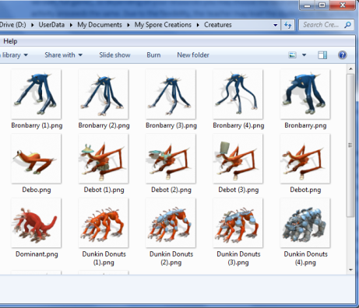
- For further help on the technical aspects of the creator, click the spore icon in the bottom left of the window (there are a lot of cool advanced tricks you can do, including shrinking/expanding parts, removing/adding joints etc.).
Student Task:
The activity tasks students with selecting two variations of each trait as dominant and recessive types for the mouth, eyes, arm number, leg number, skin color, and skin pattern trait. The students then flip a coin to randomly determine two parents’ genotypes. They create each parent in Spore and save as a separate creature. They then flip a coin again to determine which allele each parent passes on to the offspring. The students then determine the offspring’s phenotype, and create the resulting creature in Spore, saving it as another creature.
Students must then describe their offspring in a few sentences. They must also submit a picture of all three creatures in their family. They can draw them by hand, or use the Print Screen/Screen capture keyboard key/shortcut and paste the image into an image editor and crop their creature. The Spore program also saves .png’s of each created creature in a folder. To determine this folder, click the Spore icon in the bottom left, go to settings, then Game & Capture Settings. At the bottom should be a filepath that shows where the creatures go. Students may submit electronically or print the images out.
ELL Modifications:
This activity is easily accessible to English language learning students. The worksheet uses simple and direct terminology and vocabulary; with “remember” sections that define or describe key terms. The Spore program side of the activity itself is very visual, and only requires basic technology literacy to operate. Even though are few words and the terminology is unimportant to this activity, the program can be operated in multiple languages (though this is difficult and requires file modification). The genetics and inheritance content is also symbolically depicted using letters, making understanding a little easier for English language learners. Finally, the activity is hands-on and fun. This activity makes use of an entertaining and visually striking game that appeals to all students (and adults and teachers), while making great use of available 21st century technology.
Links:
http://spore2d.com/
http://www.spore.com/trial
http://store.origin.com/store/ea/en_US/DisplayProductDetailsPage/ThemeID.1252400&productID=91619200?intcmp=eaint47
Technical Note:
Requires a computer (with internet access for online 2d version) and there are also some system requirements (check store.origin.com site for details).

