Conservation of Energy and Circular Motion Lab - Teacher

Equations:
F = mv²/r
F = mg
KE = ½mv²
U = mgh

The purpose of this lab is to investigate the behavior of a metal, dye-cast hot-wheels car moving through a loop-the-loop.

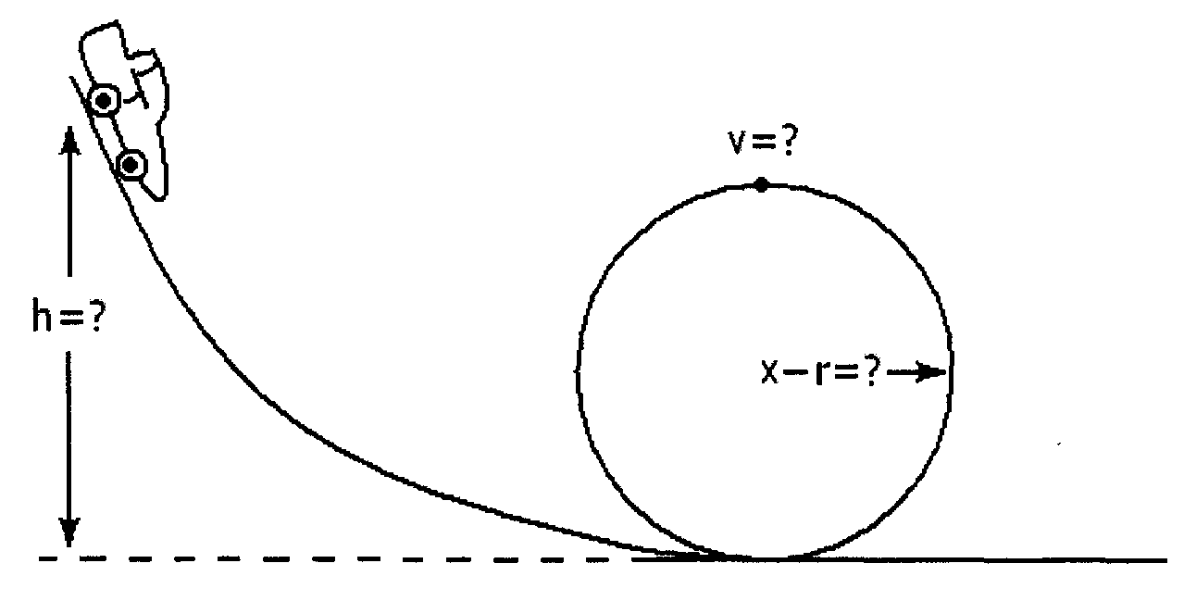

During this investigation, we will make use of energy methods as well as centripetal acceleration.

Part 1. Initial measurements
- What is the inner diameter of the track's loop-the-loop in meters (m)?

- What is the radius of the loop-the-loop in meters (m)?

- What is the mass of your car in grams (g)?

Part 2: Initial Calculations
- Using the properties of vertical circular motion, calculate the critical velocity (v), in meters/second (m/s), needed by the car to travel around the loop-the-loop losing contact with the track. Show your calculations.

F = mv²/r, F = mg
mv²/r = mg
v = √rg

- Using conservation of energy calculate the ideal height (h), in meters (m), from which the car should be released so that it will successfully complete the loop-the-loop. Show your calculations.

U = mgh, KE = 1/2mv²
mgh = 1/2 mv²
h = v²/2g

- How much initial potential energy, in Joules (J), will the car possess as it begins its trip down the track?

U = mgh

Part 3. Experimentation
- After setting up the track so that the car is able to be released from the height (h) calculated in Part 2 above, release the car to test if it is able to successfully make it through the loop-the-loop. Repeat this at least three times. Did the car remain in contact with the track through the loop-the-loop?
___ yes | ___ no

- Describe what happened.

- Which of the following reasons explains why the car did not have enough velocity (kinetic energy) to successfully make it way through the loop-the-loop,
_____ The track was slippery and the car lost traction.
_____ The speed of the car caused the loop of the track to expand and changed its radius.
_____ There was friction on the track
_____ When the car was moving through the loop, the normal force slowed it down causing a loss in kinetic energy.

- Now increase the height of the track by small intervals (1 to 2 cm) checking to see if the car successfully completes the loop-the-loop. Record your results in the table below.
Description of Behavior | Initial height  (m) | Ending height  (m)
Does not make it, falls from track
Makes it but occasionally loses contact with the track
Makes it and stays in contact with the track throughout the loop

Part 4: Conclusions
- Using the final value in your chart above for when the car was just able to complete the loop-the-loop and still remain in contact with the track calculate the car's experimental potential energy at the top of the track.

- Determine the difference between the initial potential energy (in Part 2) and the experimental potential energy (Part 4) actually needed for the car to complete the loop-the-loop.

- What does this numerical difference represent?

This difference represents the energy that is lost due to friction. This can be used to talk about how friction is a conservative force that causes the system to lose energy, thus, energy is not actually conserved. For the use of this lesson however, we pretend that energy is conserved to teach students how to relate potential to kinetic energy.

ELL Adaptations

This lesson has a number of characteristics to make it more understandable for ELL students:
- At the end of the lab there is a glossary of words and their definitions, in addition to a short listing of the various units that are used.
- There is a diagram at the beginning of the lab that shows what the set-up should look like and what the variables physically relate to.
- Parts of the diagram have been color-coded, along with various important terms.
- Physics terms and units have been put in bold to highlight their importance.
- Equations have been given at the start of the lab for students to relate back to.

Other ELL Recommendations:
- Model the activity for students so they know what it will look like.
- Have students add bolded words to their vocabulary journals.
- Guided reading of the questions asked in the lab in pairs to check for comprehension of what is being asked.

Glossary:
Diameter: The width of the loop-the-loop.
Height: How high above the ground or table you release the car.
Kinetic Energy: The energy, in joules (J), of the motion of the car.
Loop-the-loop: Circular loop of the track.
Mass: Weight of the car in kilograms. Measure using a scale.
Normal Force: The component of the contact force that is perpendicular (90°) to the surface of contact.
Potential Energy: The potential energy, in joules (J), of the car due to gravity.
Radius: Half of the diameter.
Velocity: How fast the car travels. Specifically, how many meters it travels in one second.

Units:
Acceleration: meters per second squared (m/s²)
Diameter: meters (m)
Energy: joules (J)
Height: meters (m)
Mass: grams (g)
Radius: meters (m)
Velocity: meters per second (m/s)

Reference:

Hilburn, W.A. (2011). PhysicsLAB: Conservation of energy and vertical circles. Retrieved from
http://dev.physicslab.org/Document.aspx?doctype=2&filename=WorkEnergy_RollerCoasterLab.xml

