Conservation of Energy and Circular Motion Lab - Student

Equations:
F = mv²/r
F = mg
KE = ½mv²
U = mgh

The purpose of this lab is to investigate the behavior of a metal, dye-cast hot-wheels car moving through a loop-the-loop.

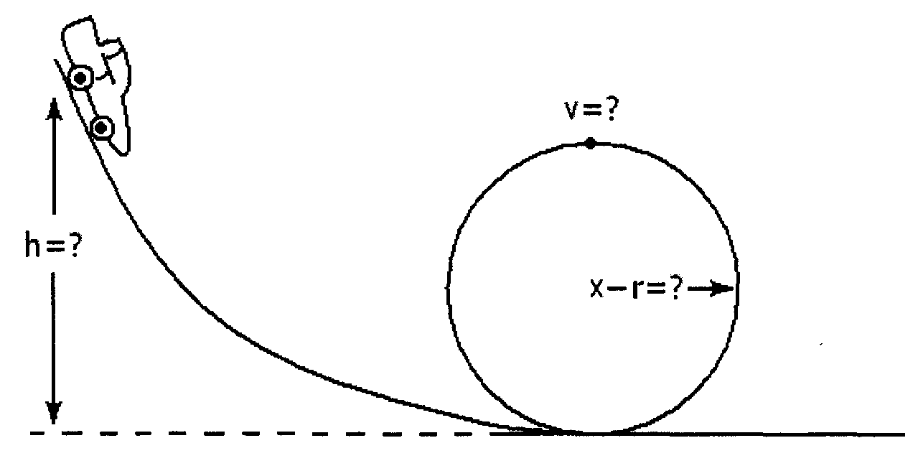

During this investigation, we will make use of energy methods as well as centripetal acceleration.

Part 1. Initial measurements
- What is the inner diameter of the track's loop-the-loop in meters (m)?

- What is the radius of the loop-the-loop in meters (m)?

- What is the mass of your car in grams (g)?

Part 2: Initial Calculations
- Using the properties of vertical circular motion, calculate the critical velocity (v), in meters/second (m/s), needed by the car to travel around the loop-the-loop losing contact with the track. Show your calculations.

- Using conservation of energy calculate the ideal height (h), in meters (m), from which the car should be released so that it will successfully complete the loop-the-loop. Show your calculations.

- How much initial potential energy, in Joules (J), will the car possess as it begins its trip down the track?

Part 3. Experimentation
- After setting up the track so that the car is able to be released from the height (h) calculated in Part 2 above, release the car to test if it is able to successfully make it through the loop-the-loop. Repeat this at least three times. Did the car remain in contact with the track through the loop-the-loop?
___ yes | ___ no

- Describe what happened.

- Which of the following reasons explains why the car did not have enough velocity (kinetic energy) to successfully make it way through the loop-the-loop,
_____ The track was slippery and the car lost traction.
_____ The speed of the car caused the loop of the track to expand and changed its radius.
_____ There was friction on the track
_____ When the car was moving through the loop, the normal force slowed it down causing a loss in kinetic energy.

- Now increase the height of the track by small intervals (1 to 2 cm) checking to see if the car successfully completes the loop-the-loop. Record your results in the table below.

Description of Behavior | Initial height  (m) | Ending height  (m)
Does not make it, falls from track
Makes it but occasionally loses contact with the track
Makes it and stays in contact with the track throughout the loop

Part 4: Conclusions
- Using the final value in your chart above for when the car was just able to complete the loop-the-loop and still remain in contact with the track calculate the car's experimental potential energy at the top of the track.

- Determine the difference between the initial potential energy (in Part 2) and the experimental potential energy (Part 4) actually needed for the car to complete the loop-the-loop.

- What does this numerical difference represent?

Glossary:
Diameter: The width of the loop-the-loop.
Height: How high above the ground or table you release the car.
Kinetic Energy: The energy, in joules (J), of the motion of the car.
Loop-the-loop: Circular loop of the track.
Mass: Weight of the car in kilograms. Measure using a scale.
Potential Energy: The potential energy, in joules (J), of the car due to gravity.
Radius: Half of the diameter.
Velocity: How fast the car travels. Specifically, how many meters it travels in one second.

Units:
Acceleration: meters per second squared (m/s²)
Diameter: meters (m)
Energy: joules (J)
Height: meters (m)
Mass: grams (g)
Radius: meters (m)
Velocity: meters per second (m/s)

Reference:

Hilburn, W.A. (2011). PhysicsLAB: Conservation of energy and vertical circles. Retrieved from
http://dev.physicslab.org/Document.aspx?doctype=2&filename=WorkEnergy_RollerCoasterLab.xml

